**Prototype-Midterm**

|  |  |
| --- | --- |
| **Student Name/ID Number:** | Agung Yuda Pratama / BDSE07-0922-076 |
| **Academic Year:** | 2022 |
| **Unit Assessor:** | Arvinder Kaur |
| **Project Title:** | CPL-Midterm |
| **Issue Date:** | 16 September 2023 |
| **Submission Date:** |  |
| **Internal Verifier Name:** |  |
| **Date:** | 16 September 2023 |

|  |
| --- |
| **Learner declaration** |
| I certify that the work submitted for this assignment is my own and that research sources are fully acknowledged.    11 September 2023  Student signature: Date: |

**Project Summary: Enhancing Customer Commerce for Jumpstart Retail Chain**

**Objectives:**

1. **Enhance Customer Satisfaction:** The primary goal of this project is to elevate customer satisfaction by providing a seamless, personalized, and engaging shopping experience across all touchpoints. This will be achieved through the development of an E-commerce website accessible 24/7.
2. **Increase Customer Loyalty:** By improving the overall customer experience, the project aims to foster stronger customer loyalty. This will be achieved by introducing promotions, discounts, and free delivery options on the E-commerce platform.
3. **Drive Revenue Growth:** Improved customer experience is expected to lead to increased sales and conversions, contributing to the overall revenue growth of the Jumpstart retail chain.
4. **Optimize Operational Efficiency:** The project will implement technology solutions and process automation to streamline operations, reduce manual tasks, and minimize errors.

**Scope:**

* Development of an E-commerce website with responsive design, interactive product presentation, and consistent UI design.
* Implementation of technology solutions to enable 24/7 customer access.
* Enhance customer experience through promotions, discounts, and free delivery options.
* Conducting surveys and research to gain insights into customer preferences and behaviors.

**Requirements:**

* **Technical Requirements:** The project necessitates hardware upgrades such as processors and RAM, software requirements including Windows 10/11 and CMS (WordPress), and specific frameworks like WooCommerce, Elementor, Formidable, and Chaty.
* **Market Survey:** This involves assessing customer satisfaction with the current system, tracking product availability and stockouts, and understanding the influence of competitors on customer choices.
* **Operational Feasibility Study:** This includes evaluating current processes, analyzing human resource needs, assessing technical resource availability, ensuring data readiness, and addressing legal and regulatory compliance.
* **Financial Considerations:** A detailed cost-benefit analysis has been conducted to estimate project costs and benefits, including expenses for hardware, software, training, and implementation.

In conclusion, the project aims to leverage technology to enhance customer commerce for Jumpstart Retail Chain by improving customer satisfaction, increasing loyalty, driving revenue growth, and optimizing operational efficiency, all while adhering to technical, market, operational, and financial requirements outlined in the proposal.

**A brief description of the technologies, programming languages, and frameworks used to develop the E-commerce website for Jumpstart Retail Chain:**

**Technologies:**

1. **CMS (Content Management System):** The website will be built using WordPress, a popular CMS that provides a user-friendly interface for content management, making it easy to update and maintain the site's content. **WordPress 6.3.1**
2. **Web Hosting:** The website will be hosted on a web server to make it accessible online. Hosting services like Pantheon will be used to ensure reliability and performance.

**PANTHEON**

1. **Database Management System (DBMS):** A DBMS will store and manage product, customer information, and transaction data.
2. **Web Browsers:** The website will be designed to be compatible with major web browsers such as Google Chrome, Mozilla Firefox, and Microsoft Edge to ensure a consistent and accessible user experience.

**Programming Languages:**

1. **HTML (Hypertext Markup Language):** HTML will be used to structure the content of web pages, defining elements like headings, paragraphs, lists, and links. **HTML 5**
2. **CSS (Cascading Style Sheets):** CSS will style and format the website's layout, defining aspects like fonts, colors, and responsive design for different screen sizes. **CSS 3**
3. **JavaScript:** JavaScript, a versatile scripting language, will be utilized to enhance the website's interactivity and user experience. It can be used for client-side validation, dynamic content updates, and interactive features. **JavaScript ES6**
4. **PHP (Hypertext Preprocessor):** PHP will be used for server-side scripting to handle dynamic content generation, database interactions, and server-side processing. It enables the website to perform tasks like user authen

**Frameworks:**

1. **WooCommerce v2.2.2:** WooCommerce is an e-commerce plugin for WordPress providing a framework for managing product listings, shopping carts, checkout processes, and payment gateways. It's highly customizable to suit the specific needs of the E-commerce website.
2. **Elementor v3.15.3:** Elementor is a popular page builder plugin for WordPress that creates custom page layouts using a drag-and-drop interface. It simplifies the design and customization of web pages, making them user-friendly for website administrators.
3. **Astra:** Astra is a lightweight and highly customizable WordPress theme that can be used as a framework for designing the website's layout and appearance. It offers flexibility and performance optimization.
4. **Formidable v6.4.2:** Formidable is a form builder plugin for WordPress, which can be used to create and manage forms for various purposes on the website, such as contact forms, surveys, and feedback forms.
5. **Chaty v3.1.4:** Chaty are plugins or tools that can be integrated into the website to provide real-time chat support and engage with customers, enhancing the overall customer experience.

**The Design of The Website**

**HomePage**

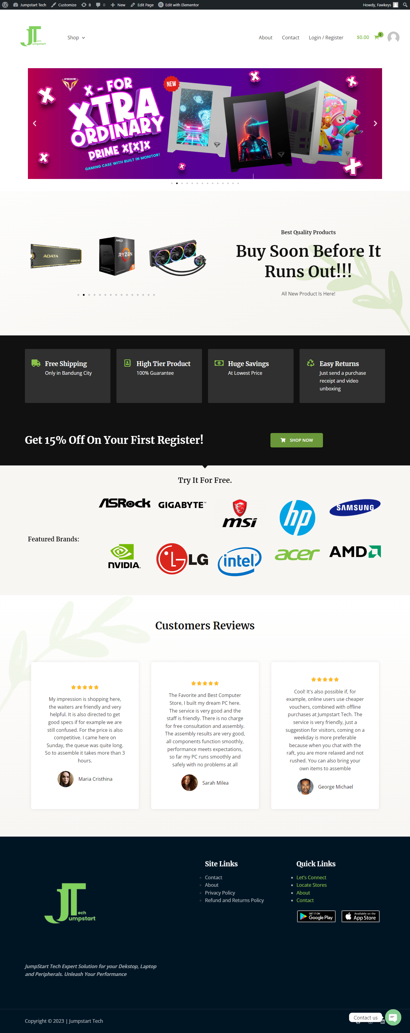

**Contact Us**

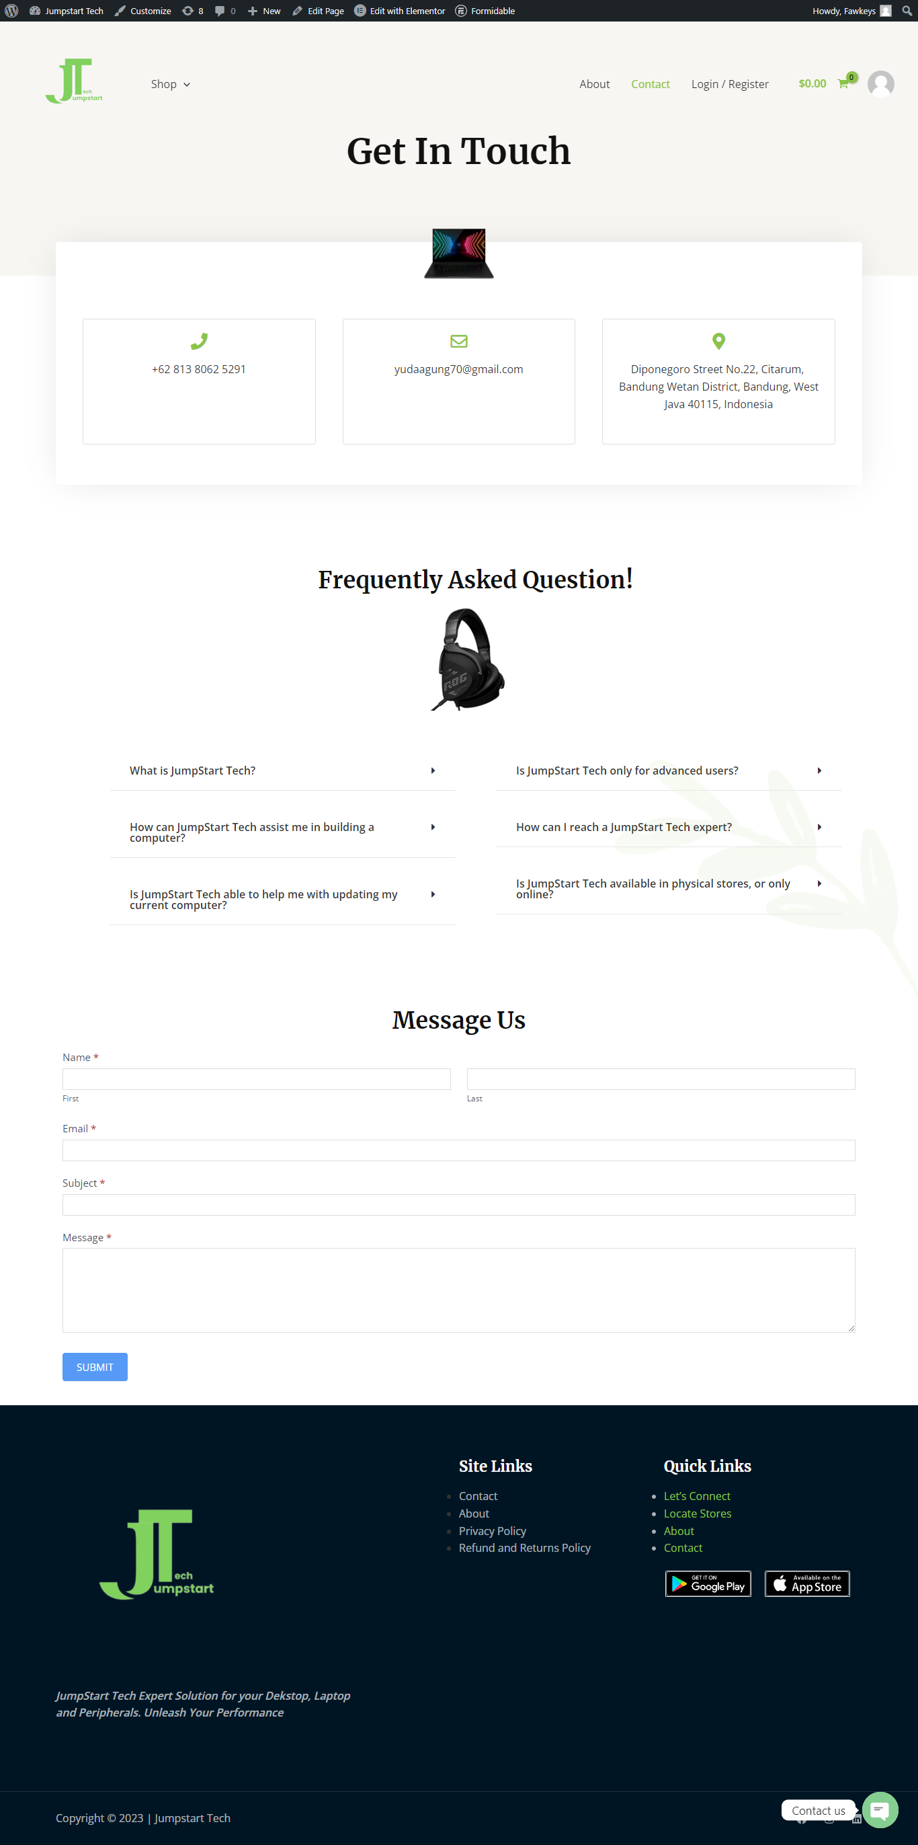

**About Us**

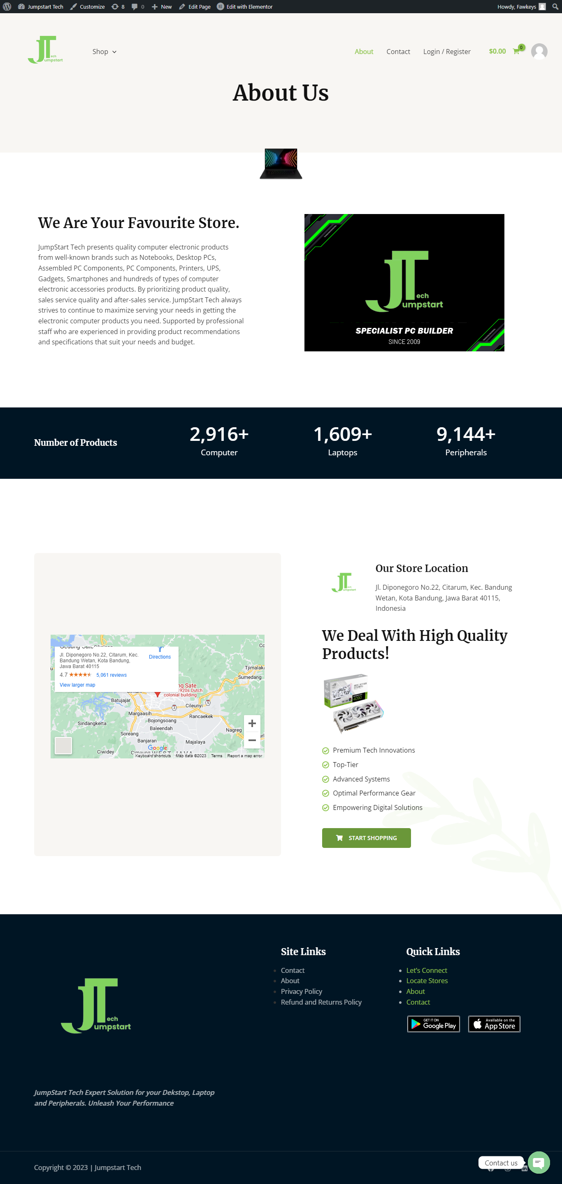

**Privacy Policy**

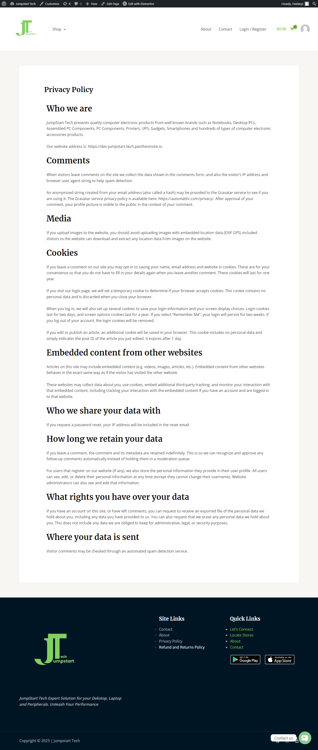

**Refund Policy**

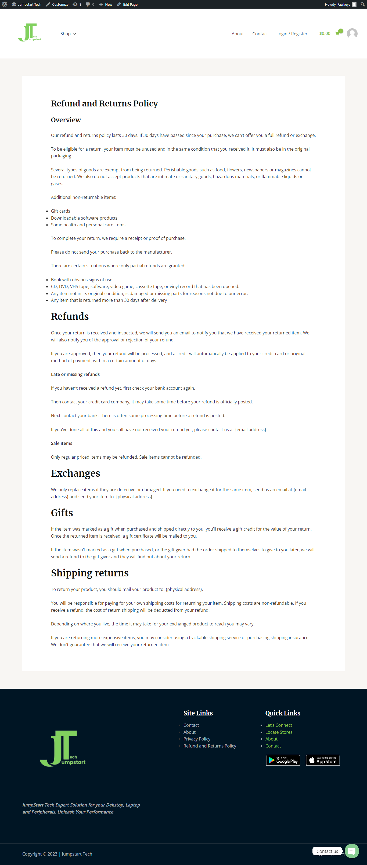

**Login**

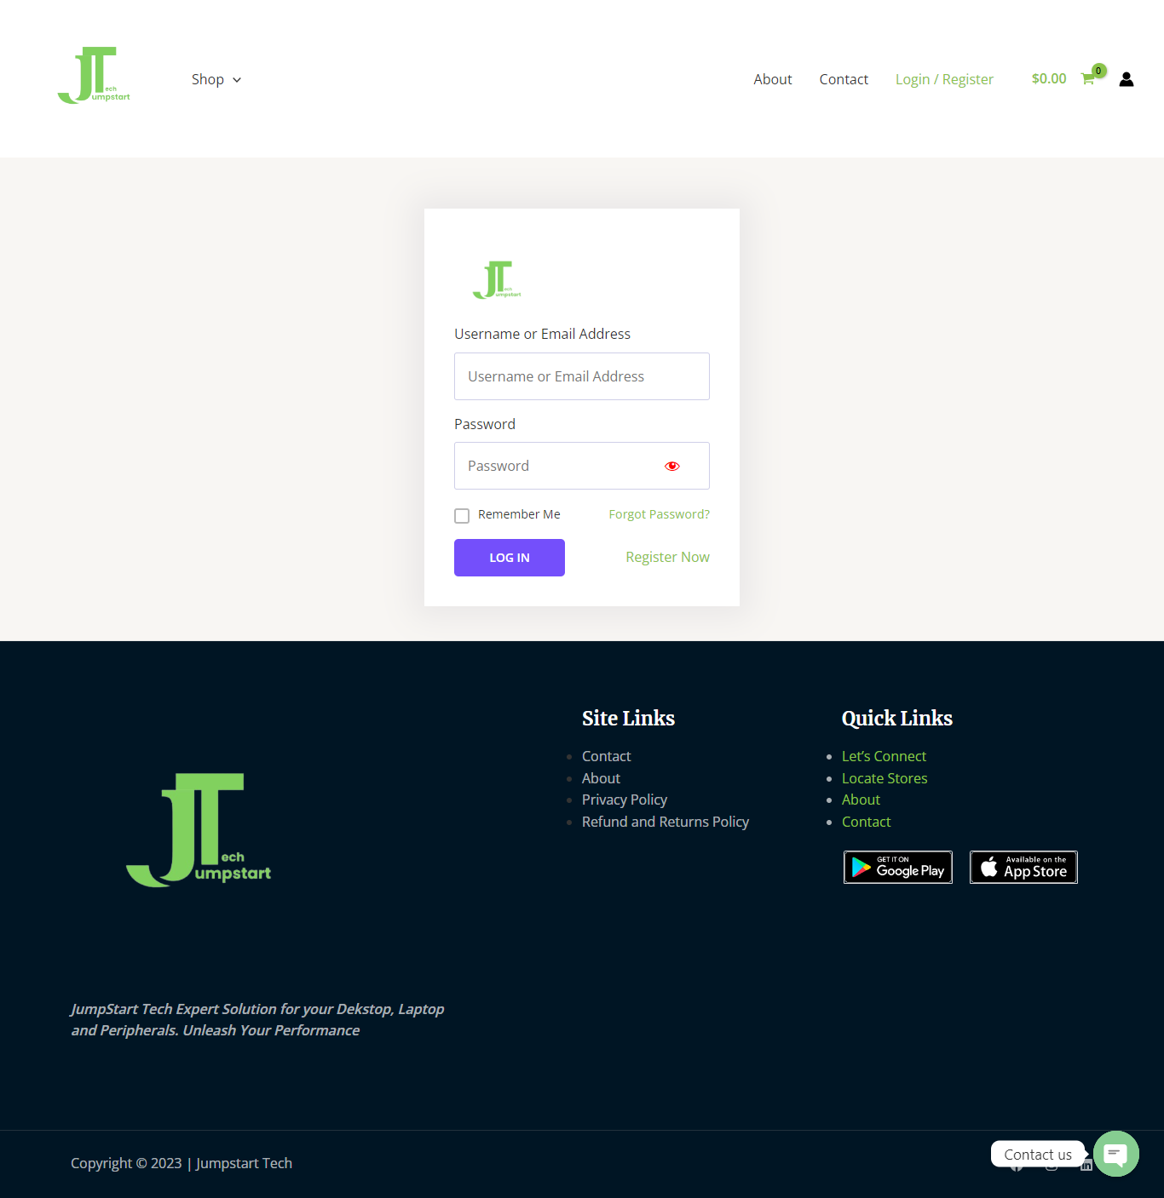

**Register  
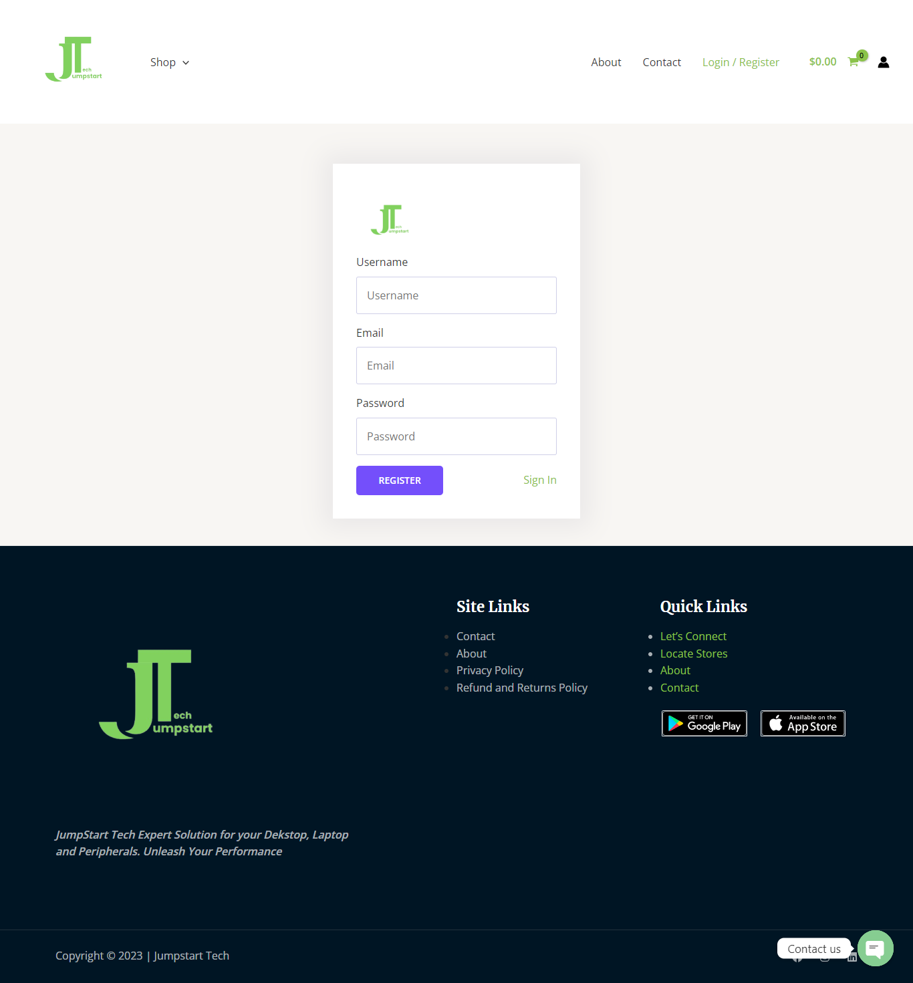**

**Core Functionality and Implemented Features:**

1. **E-commerce Platform:** The website serves as an E-commerce platform, allowing customers to browse and purchase products from Jumpstart Retail Chain online.
2. **Product Listings:** Implemented product listings with detailed descriptions, images, and pricing information.
3. **Shopping Cart:** A shopping cart feature has been integrated, enabling users to add and manage items before checkout.
4. **User Accounts:** User registration and account management functionality have been developed, allowing customers to create accounts, log in, add products to the chart, and check out products.
5. **Search Functionality:** Implemented a search bar that enables users to search for specific products or categories quickly.
6. **Responsive Design:** The website is designed to be responsive, ensuring a seamless experience on various devices, including desktops, tablets, and mobile phones.
7. **Promotions and Discounts:** Implemented promotional features, including discounts and free delivery options, to incentivize purchases and enhance customer loyalty.

**Planned Features for Remaining Development:**

1. **Real-time Inventory Updates:** Integration of real-time inventory updates to provide customers with accurate product availability information.
2. **Customer Reviews and Ratings:** Implementation of customer review and rating functionality to allow customers to share their feedback and experiences.
3. **Related Products:** Add a "related products" section to suggest complementary items to customers, encouraging cross-selling.
4. **Secure Payment Processing:** Integration of secure payment gateways to facilitate online payments, ensuring the safety of customer financial information.
5. **Advanced Search Filters:** Enhancing the search functionality with advanced filters, such as price ranges, brand filters, and sorting options.
6. **Customer Support Chat:** Integration of a real-time customer support chat feature, utilizing tools Chaty to provide immediate customer assistance.

**Sample Code Snippets:**

* 1. Functions.php  
     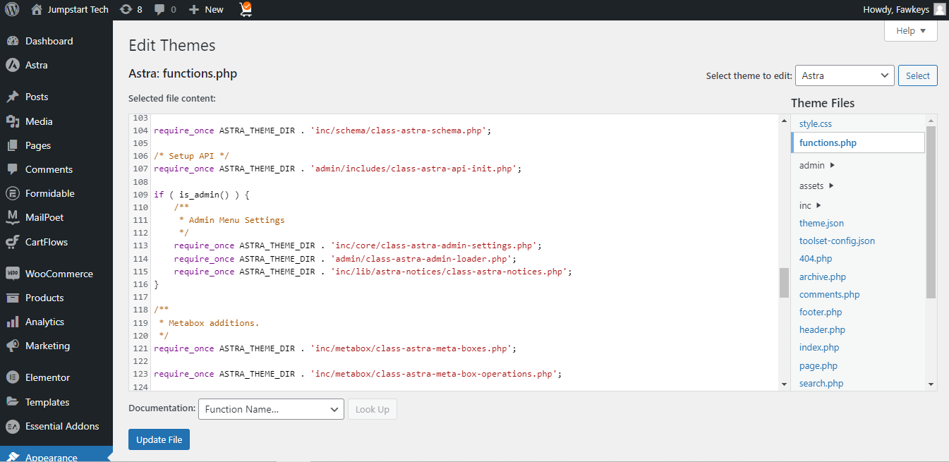
  2. Page.php  
     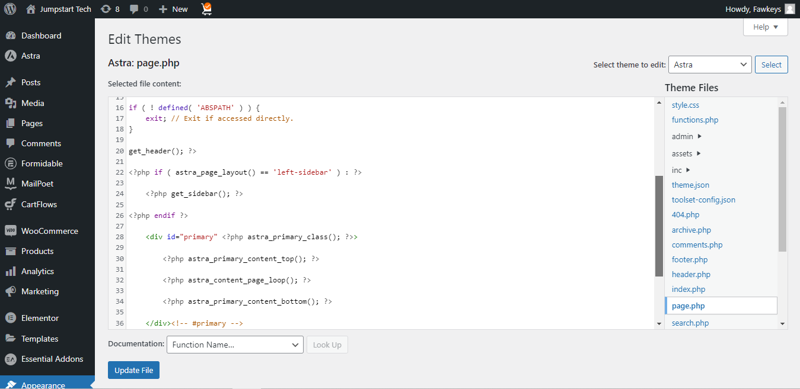
  3. Search.php  
     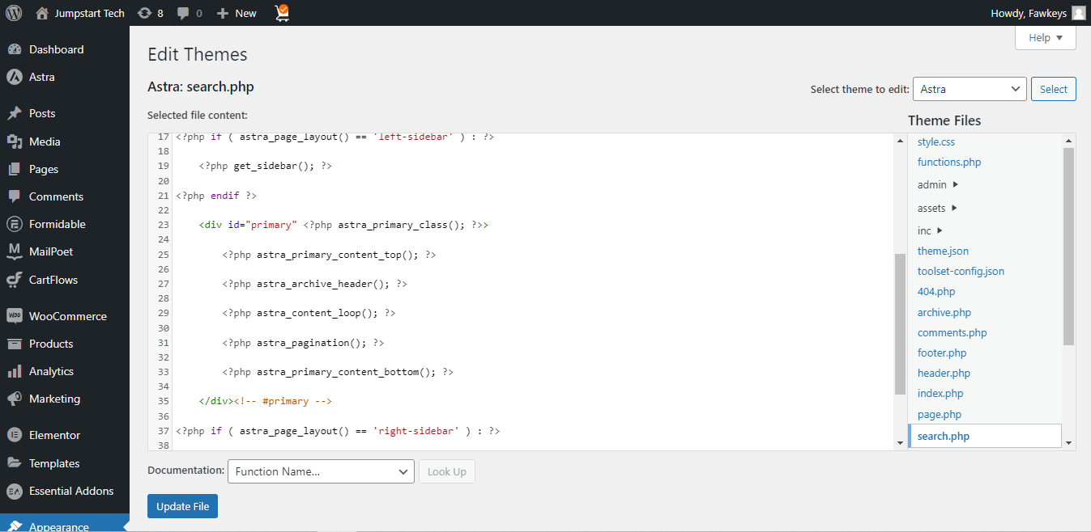
  4. Index.php  
     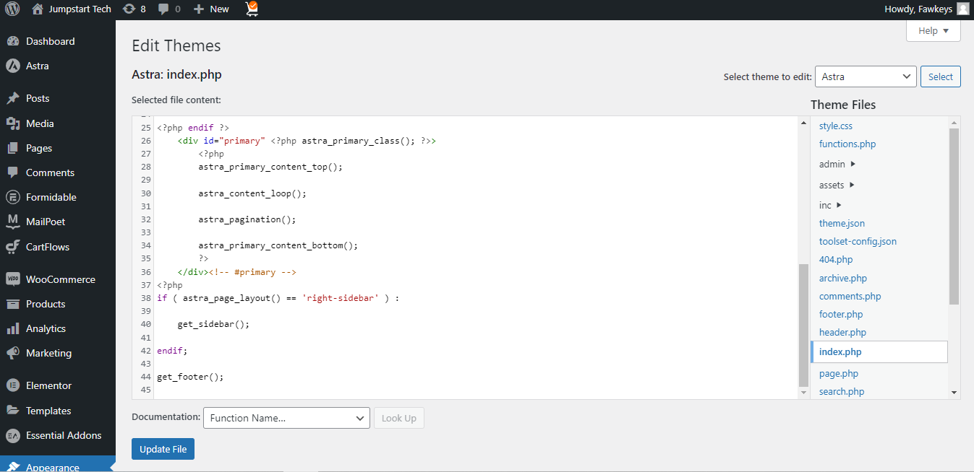
  5. Footer.php  
     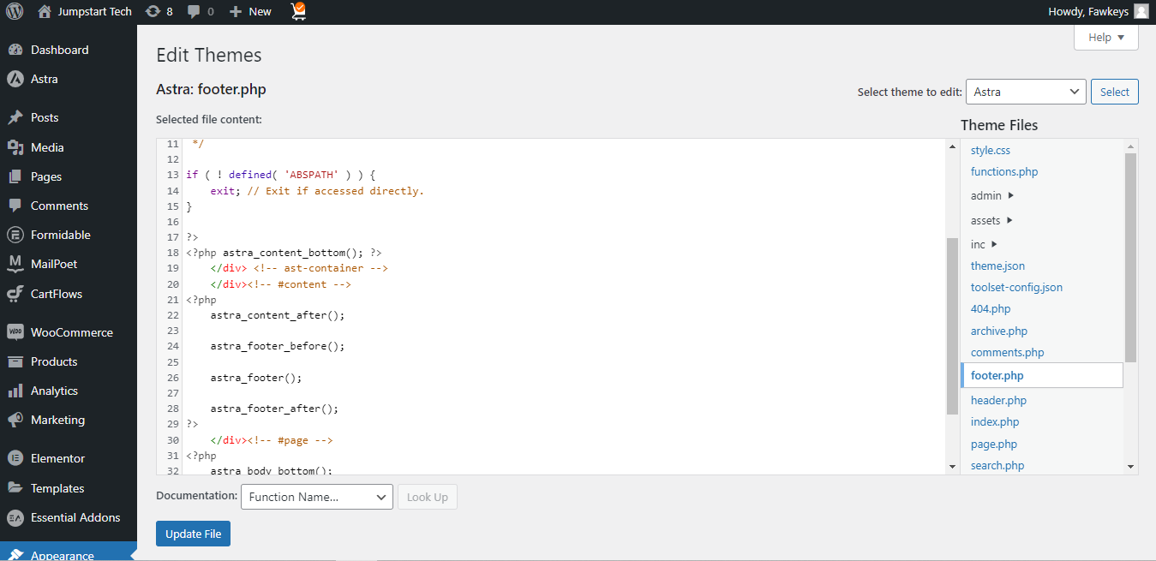

**Database Design:**

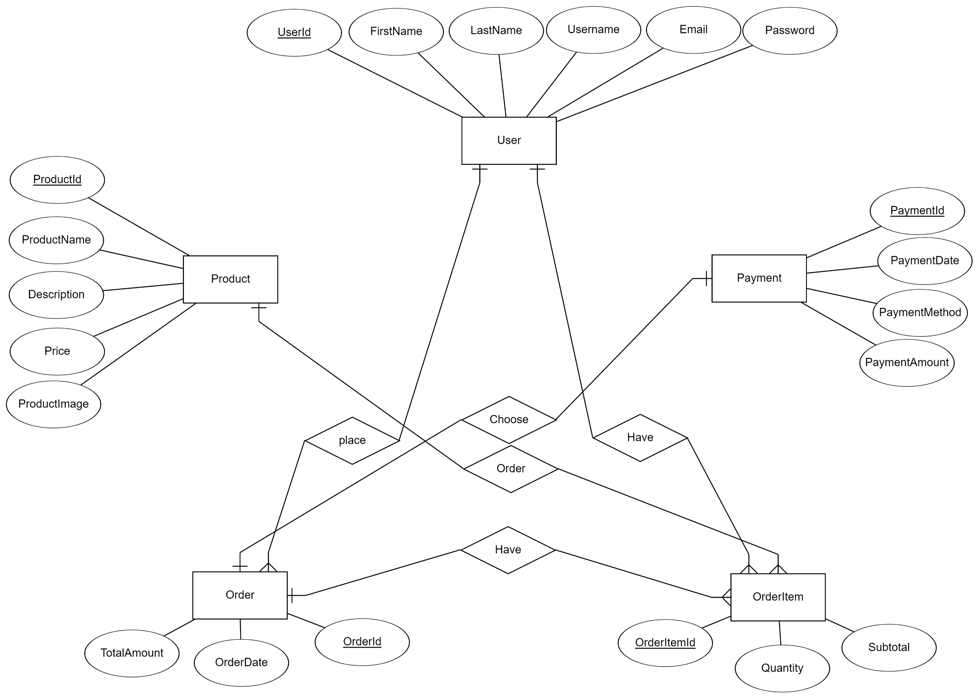

**Relation Schemas:**

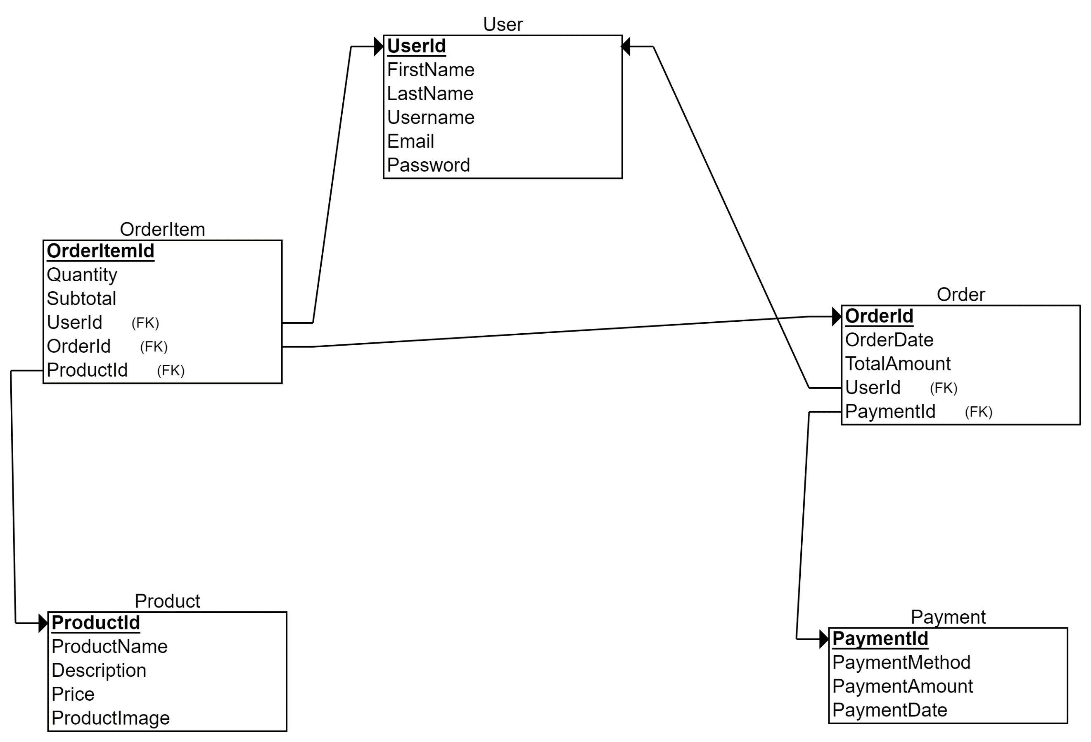

A detailed roadmap or timeline for the remaining tasks and deliverables and any changes or updates to the original project plan.

**The Scheduled Plan**

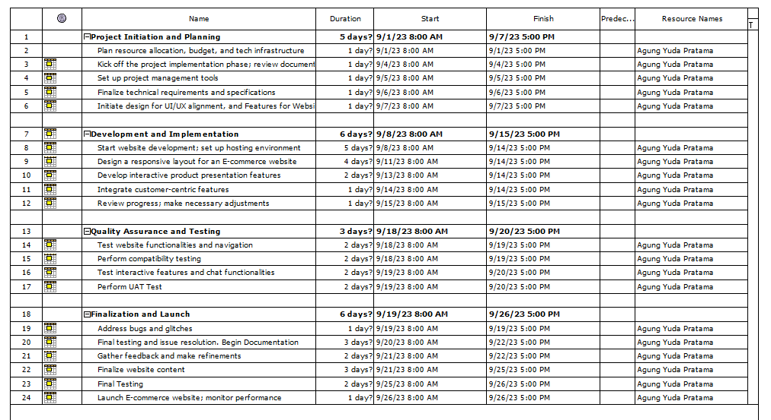

**The** **Remaining Task:**

* 1. **Product Presentation**
  2. **Product Search**
  3. **Product Filter**
  4. **Checkout**
  5. **Payment Gateway**
  6. **UAT Testing**